
A14
Sreenidhi Institute of Science & Technology
(An Autonomous Institution)
Code No: 4U101
M. TECH. I – Year I – Semester Examinations, March/April 2015, (Regular)
DIGITAL SYSTEM DESIGN (Common to DSCE and VLSI & ES)

Time: 3 Hours Max. Marks: 60

Note: No additional answer sheets will be provided.

Part - A
Max.Marks:10

Answer all QUESTIONS.
1. List out some important features of FPGA.
2. Write the Boolean difference of a logic function F(X) with respect to an input variable x_{i}.
3. Define transition count. What is the transition count of the response sequence Z=10011010.
4. What are the two different approaches to the problem of finding tests for sequential circuits?
5. What is foldable compatibility matrix (FCM)?
6. What are the components of state machine chart? Discuss with an example.
7. How to detect multiple faults in the two-level AND-OR network using Kohavi algorithm?
8. What are the advantages of PLA minimization and folding?
9. What is meant by implied compatibility classes for a given incompletely specified sequential machine (ISSM)?
10. Define races and cycles in sequential circuits.

Part – B
Max. Marks: 50

ANSWER ANY FIVE QUESTIONS. EACH QUESTION CARRIES 10 MARKS.

1. a) Draw an ASM chart to design a control logic of a binary multiplier. Realize the same using multiplexer, decoder and D-type flip-flops. (7M)
b) What is one-hot state assignment? Explain with an example. (3M)

2. a) Explain the need of logical fault models in digital circuit testing. Discuss in detail, the single struck-at fault models and bridging fault models. (3M)
b) Consider the circuit shown in figure below. Sensitize each path in this circuit to obtain a complete test set that comprises a minimum number of tests. (7M)
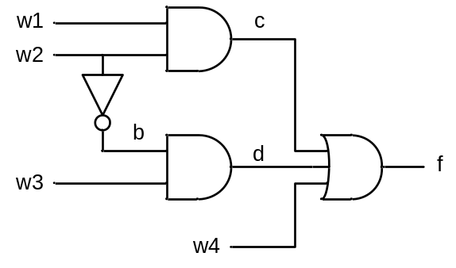

3. a) Describe the approach of exhaustive and pseudo-random testing of VLSI circuits.
b) Explain random testing method for combinational circuits.

4. a) Describe the design of fault detection experiments for the sequential circuits.
b) Discuss the various approaches of fault diagnosis in sequential circuits.

5. a) Describe PLA folding with an example.
b) Describe various faults that may occur in PLAs. Also explain how faults are detected in PLAs.

6. a) Find a reduced state machine that covers the machine of table below. (7M)
Present State | Next State, Z
Present State | X₁ X₂
Present State | 00 | 01 | 11 | 10
A | B,0 | D,0 | G,1 | A,0
B | C,1 | G,1 | E,0 | B,1
C | D,1 | G,1 | A,0 | C,1
D | F,1 | H,1 | A,0 | D,1
E | C,0 | F,0 | H,1 | E,0
F | B,1 | H,1 | E,0 | F,1
G | A,0 | E,0 | B,1 | D,0
H | E,0 | A,0 | C,1 | F,0

b) Explain briefly the occurrence of various types of hazards in digital circuits. (3M)

7. Determine the Boolean difference for the following functions:
i)

ii)

8. Explain the following:
i) Limitations of Finite State Machines
ii) State Identification and Machine Identification

-- 00 -- 00 --

